In-fact in java, multiple inheritance of classes itself is not allowed becoz of this problem…Lets move on to java for some time;

Becoz of the above problem, multiple inheritance of classes is not allowed. So interfaces are introduced to solve multiple inheritance problem
Interfaces:
Classes that have only abstract methods(pure virtual functions). It cannot have a method body.
Abstract classes:
Class that can have both abstract methods and non abstract methods
Classes:
No abstract classes are allowed.

There are two ways to achieve abstraction in java
- Abstract class (0 to 100%)
- Interface (100%)

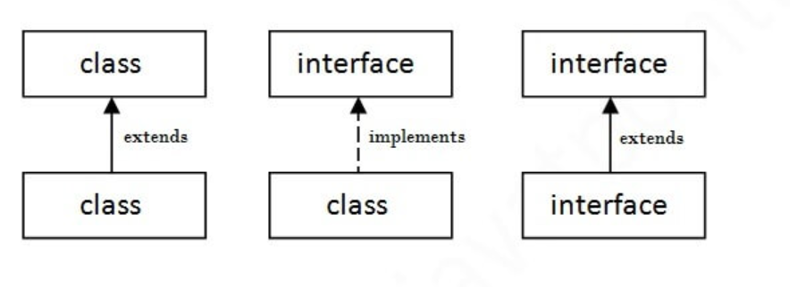

There are mainly three reasons to use interface. They are given below.
- It is used to achieve abstraction.
- By interface, we can support the functionality of multiple inheritance.
- It can be used to achieve loose coupling. (car engine example)

Multiple inheritance in Java by interface:
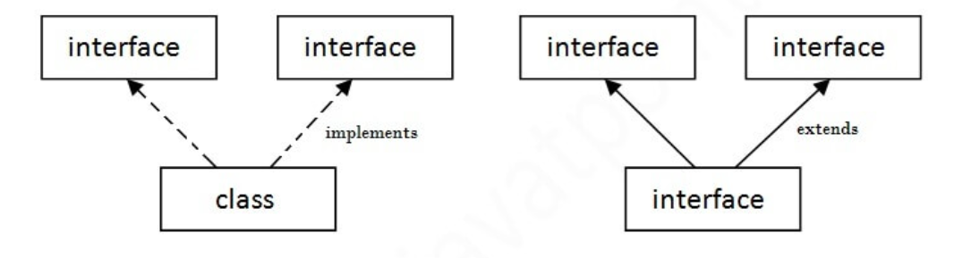
It is possible in interface because there is no definition of functions WRT base classes
We will define them in the derived class. So compiler will have a clear idea which method to invoke

- interface Printable{
- void print();
- }
- interface Showable{
- void print();
- }

- class TestInterface3 implements Printable, Showable{
- public void print(){System.out.println("Hello");}
- public static void main(String args[]){
- TestInterface3 obj = new TestInterface3();
- obj.print();
- }
- }
Output : Hello

Inheritance: (is-A)
class vehicle{
}
class car extends vehicle{
}
Every car is-a vehicle

Association: (has-A)
class Engine{
}
class Car{
Engine e;
Car(Engine e1)
e = e1;
}
car has-a engine
has-a is relatively less tightly coupled than is-a
because car may still exist without an engine i.e less dependency among the classes
aggregation and composition:
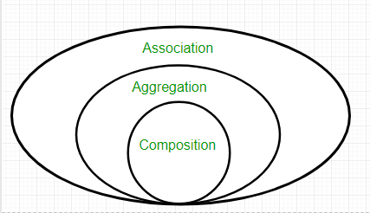
association = weak bond
composition = strong bond (remember CS)
Ex:
a car has-a music player = association
a car has-a engine = composition
if car don’t exist music player can exist independently but engine cannot exist independently
In video streaming
a playlist has-a video = association
a video has-a subtitles = composition
if playlist doesn’t exist, video can exist independently if it want to exist but without video subtitles wont exist

WKT has-a is relatively less tightly coupler than is-a
but has-a can be still made to couple loosely using interface
class dieselEngine{
}
class petrolEngine{
}
class Car{
dieselEngine d;
Car(dieselEngine d1)
d = d1;
}
If we want to change the engine of the Car… we have to modify the definition of the Car

Interface engine{
}
class dieselEngine implements engine{
}
class petrolEngine implements engine{
}
class Car{
engine e;
Car(engine e1)
e = e1;
}
main(){
dieselEngine d;
Car car = new Car(d);
petrolEngine p;
car = new Car(p)
}

SOLID principles:
1.Single responsibility principle:
a class should have only one reason to change.
ie a class should only have single responsibility
Suppose we have a class that handles both saving user information to the database and sending email notifications:
class customclass {
private String userName;
private String email;

public void saveUser() {
// Code to save user information in the database
}

public void sendWelcomeEmail() {
// Code to send a welcome email
}
}
Changes to email-related code would require modifying this class even if there’s no need to alter the user-saving functionality.

class UserRepository {
public void saveUser(User user) {
// Code to save user
}
}

class EmailService {
public void sendWelcomeEmail(User user) {
// Code to send email
}
}

2.Open Closed principle:
A class should be open for extension but closed for modification
Lets say there is a Notification class which send EMAILs and SMS

class Notification {
public void sendNotification(String type, String message) {
if (type.equals("EMAIL")) {
//sends email
} else if (type.equals("SMS")) {
//sends SMS
}
}
}

Lets say we want to add a new functionality push notifications
Ex: "You have a new friend request from Jane Doe!", Zomato notifications
We have to modify our class if we follow above convention
So make use of interfaces.
interface Notification {
void send(String message);
}

class EmailNotification implements Notification {
public void send(String message) {
//sends email
}
}

class SMSNotification implements Notification {
public void send(String message) {
//sends SMS
}
}

class PushNotification implements Notification { // We will replace this later
public void send(String message) {
//sends push notifications
}
}

3.Liskov Substitution Principle (LSP)
if you have a function that works with a superclass, it should also work with any subclass
without effecting the correctness
We know that every square is a rectangle (is-a relationship)
so square extends rectangle

class rectangle{
public int length;
public int breadth;

public void setlength(int length)
this.length = length;
public void setbreadth(int breadth)
this.breadth = breadth
}

Class square extends rectangle{
}

Lets say there is a function that takes rectangle object and sets the length and breadth of rectangle object.

void fun(rectangle r)
r.setlength(5):
r.setbreadth(3);
}
as every square is a rectangle and a square is suppose to compatible with the function
But it effects the correctness of square.
So solution is

interface shape{
}
class rectangle implements shape{
}
class square implements shape{
}

4.Interface Segregation Principle :
A class should not contain methods with no use.

widget->(button, textbox)

Interface widget{
public void handlemouseclick()
pubic void handlekeyboardinput()
}

class button implements widget{
}

class textbox implements widget{
}

button has nothing to do with handlekeyboardinput() method. But we have to implement a dummy method inside button class.

So we have to extend another interface from widget named textwidget

Interface widget{
public void handlemouseclick()
}

interface textwidget extends widget{
pubic void handlekeyboardinput()
}

class button implements widget{
}

class textbox implements textwidget{
}

5. Dependency inversion principle: (Somewhat unclear, treat it as separate don’t link with others)
High level modules should not depend on low level modules
Both should depend on abstractions
